Lab Guide 3:

Deployment:
Q.1 Create A deployment using CLi Method using quay.io/mayank123modi/myapache image and deployment name should be test1.
Q.2 Create A deployment using dryrun Method using quay.io/mayank123modi/myserver image and deployment name should be test2.
Q.3 Create a deployment using image quay.io/mayank123modi/simple-webapp.

Ans: 1
oc create deployment test1 --image quay.io/mayank123modi/myapache
oc get deployments.apps
oc get all
oc get rs
oc get pods
oc describe deployments.apps test1
oc describe rs <rs name>
oc describe pod test1-59bcf5dfd-6sf2l
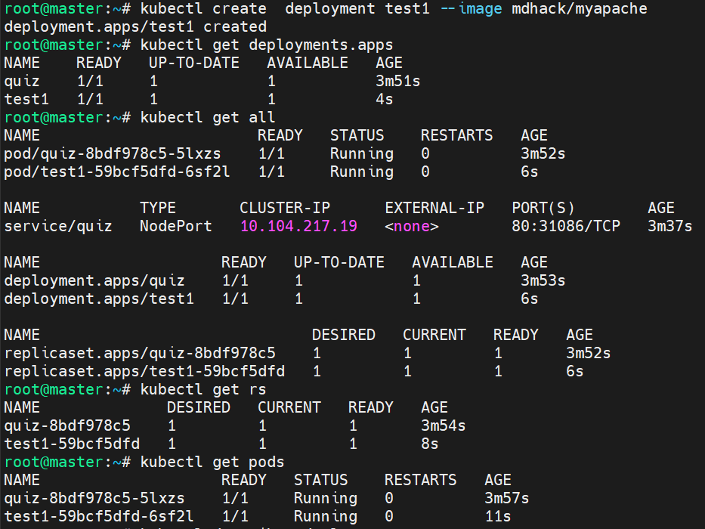
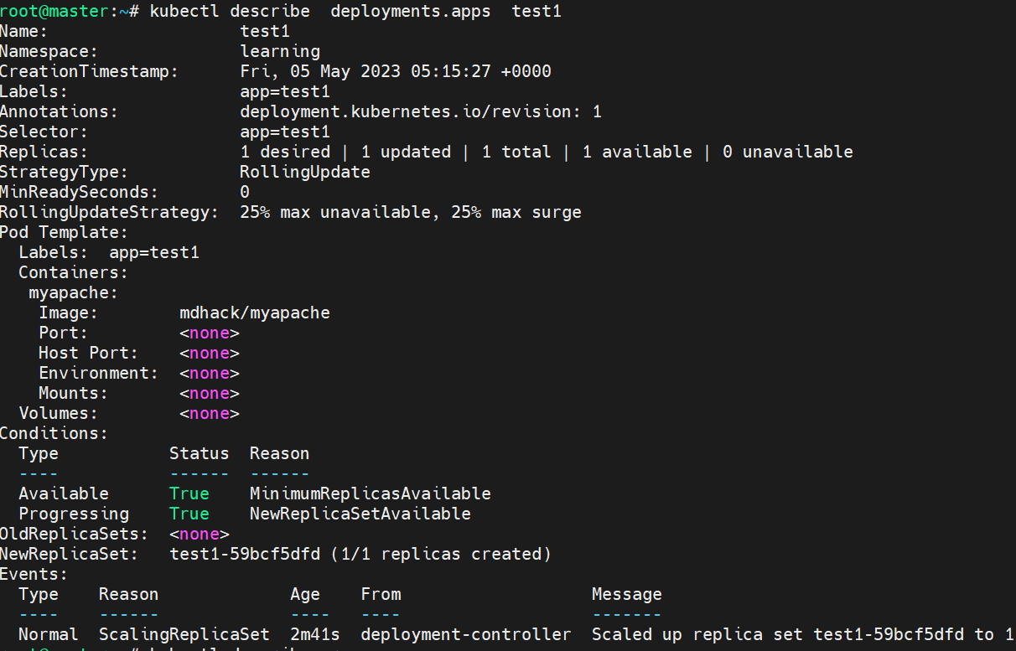
Ans: 2
oc create deployment test2 --image quay.io/mayank123modi/myserver --dry-run -o yaml > dep1.yaml
cat dep1.yaml
oc create -f dep1.yaml
oc get pods
oc get rs

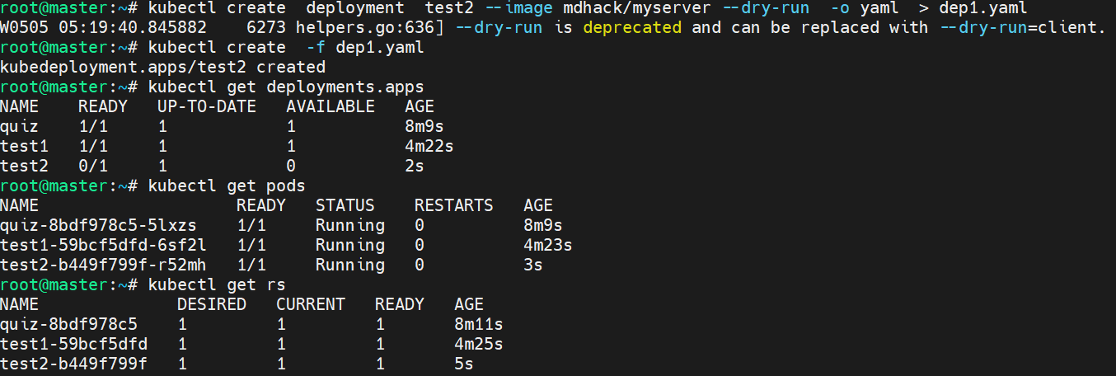
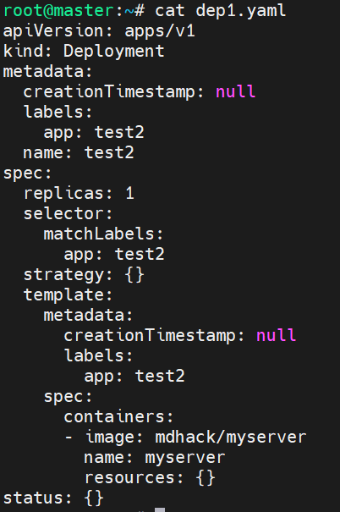

Ans: 3
oc create deployment anyname --image quay.io/mayank123modi/simple-webapp
oc get deployments.apps
oc get pods
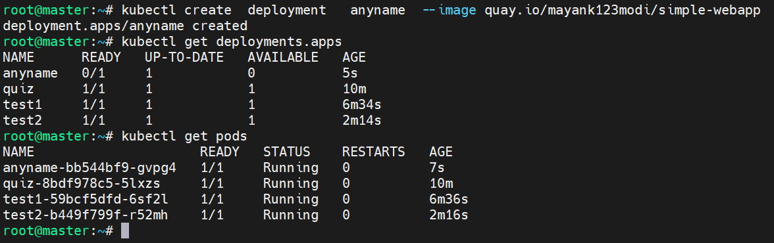

Clean up your environment

